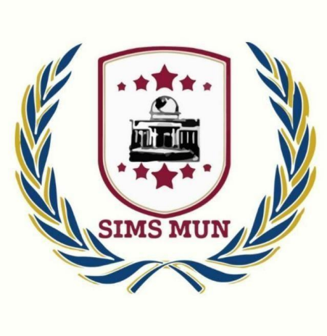
SIMS INTER MUN 2023

OPENING CEREMONY REPORT
SKILL DEVELOPMENT

Compiled by SIMS MUN Society

Symbiosis Institute of Management Studies, Pune
To: The Director
From: SIMS MUN Society
Respected Sir,
Subject: Report on Opening Ceremony of SIMS INTER MUN 2023 held on 26th and 27th August 2023

SIMS INTER MUN 2023 was organized by SIMS MUN Society on 26th and 27th August 2023. The SIMS motto, “Make a Difference” resonates in the auditorium at SIMS on a sprightly Saturday morning, as the opening ceremony sets the tone for the SIMS Inter MUN 2023. The ceremony commenced with a formal address by Brig. Dr. Rajiv Divekar, highlighting how Model United Nations conferences provide a platform for students to engage in meaningful discussions, simulations, and debates on various global issues. He also highlighted that every single one of us has the power to bring about positive change, we may not be able to solve all the problems in society, but we can make a difference in our own communities, in our own neighborhoods, and in our own families.
He went on to welcome the Chief Guest for the event, Amb. (Retd.) Manjeev Singh Puri, Former representative of India to EU, Belgium, Luxembourg, and Nepal, with a token of gratitude. Amb. Manjeev Singh Puri addressed the August gathering with his words of wisdom and shared snippets of his life experiences and the role India has played till now and will be playing in modelling the future of Model United Nations. He applauded the initiative taken by SIMS to promote an interdisciplinary approach to diplomacy and international relations through this MUN.
The ceremony went on to an enthralling Question Answer session with the audience on a myriad of topics, ranging from the role of diplomacy to multilateralism, where the students gained Amb. Puri’s valuable insights on pressing world issues before the delegates moved on to a day of discussion, debate, and dissolving dilemma.
The event was well received by the audience. Attached along with this letter, is a brief report of the ceremony and the events that happened during the session. The event was successfully organized under the guidance of Dr. Smita Mehendale, faculty in-charge SIMS MUN Society and leadership of Ankush Dhiman, Secretary General of SIMS MUN Society, and Anubhab Chattopadhyay, Deputy Director General of SIMS MUN Society.
As we grow with your support and guidance, we hope to organize many such events in the future.
Sincerely
SIMS MUN Society

Report

S.No. | Activity | Remarks
1. | Topic | India as a leading power
2. | Duration and venue | Date:26th August 2023  Time: 10 AM to 11:30 AM  Venue: SIMS Auditorium
3. | Invitations | - Honourable Chief Guest Amb. (Retd.) Manjeev Singh Puri  - Director SIMS, Brig. (Dr.) Rajiv Divekar  - Faculty In-charge Dr. Smita Mehendale  - Participants of SIMS INTER MUN 2023 and Transformational Student Managers of SIMS
4. | Participants | - 97 Delegates  - 12 International Press members  - 5 Executive Board members  - 16 Transformational student managers
5. | Objectives | - To discuss the rise of India as a global superpower in the current geopolitical scenario  - To understand how to compete in the world order and gain respect and power in a diplomatic fashion.
6. | Outcomes | A successfully concluded event that helped students hone up their debating skills and know about the various international geopolitical scenarios.

Table Programme

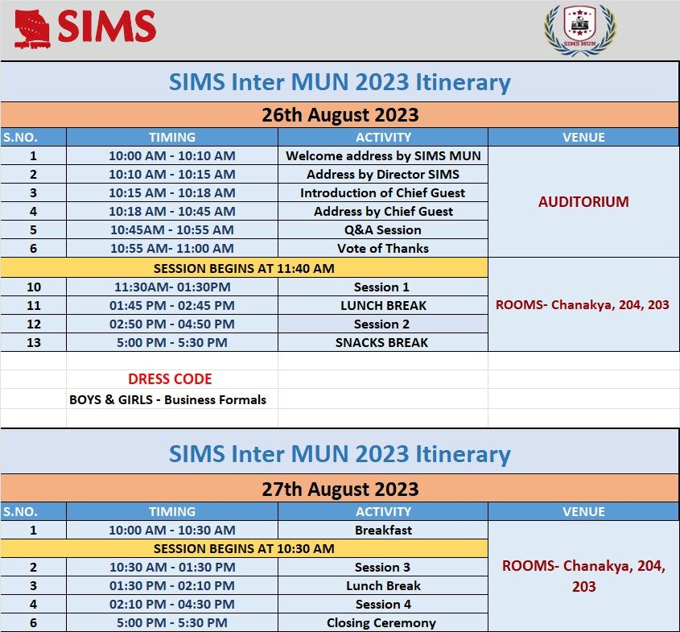

SIMS INTER MUN 2023
Day 1 of SIMS INTER MUN 2022 started off with the inaugural session which was addressed by our honourable chief guest Amb. (Retd.) Manjeev Singh Puri, Former representative of India to EU, Belgium, Luxembourg, and Nepal. The session witnessed the presence of Brig. (Dr.) Rajiv Divekar, Director of SIMS. Assistant Prof. Dr. Smita Mehendale, faculty in charge of SIMS MUN Society; and participants of SIMS INTER MUN 2023. Post the inaugural session the delegates moved to their respective committees to start the discussion. There were three committees this year namely, UNHCR, UNGA, and the International Press. Amb. (Retd) Manjeev Singh Puri imparted knowledge and wisdom to the student managers through his guest talk on the topic, “India as a leading power”. The address was inspiring and thought-provoking.
He further talked about the importance of being a member nation of the United Nations and the importance of each vertical that the United Nations has to offer. He imparted knowledge about the great personalities of defence field, their contributions and sacrifices towards the nation and how India plays a paramount role in the current geopolitics of the world.
He also spoke about how the social media also plays an important role in international politics and how even a single misspoken word can lead to a plethora of misinterpretations.
His insightful address was followed by an enthusiastic Q&A session, and all the answers were addressed by the guest with great consideration and deliberation The delegates and EB’s went to their respective committee rooms as the event began in its earnest.

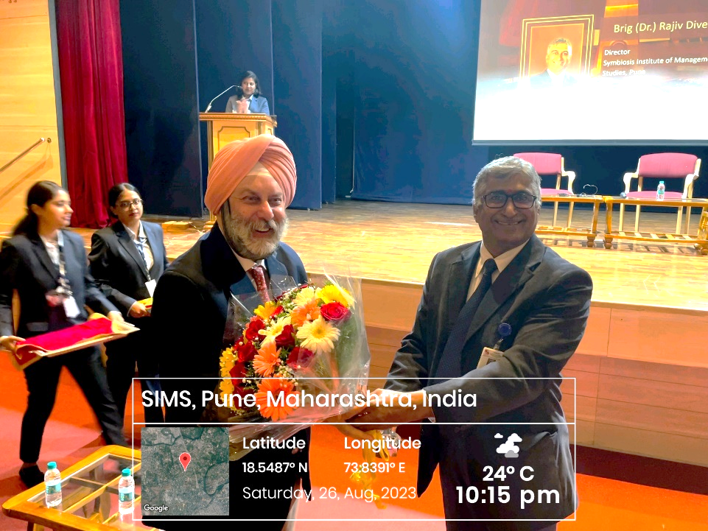
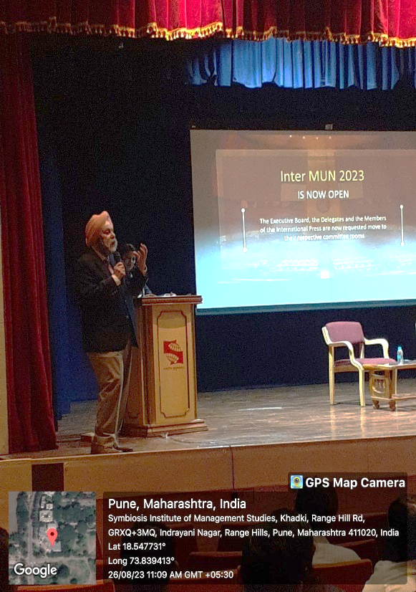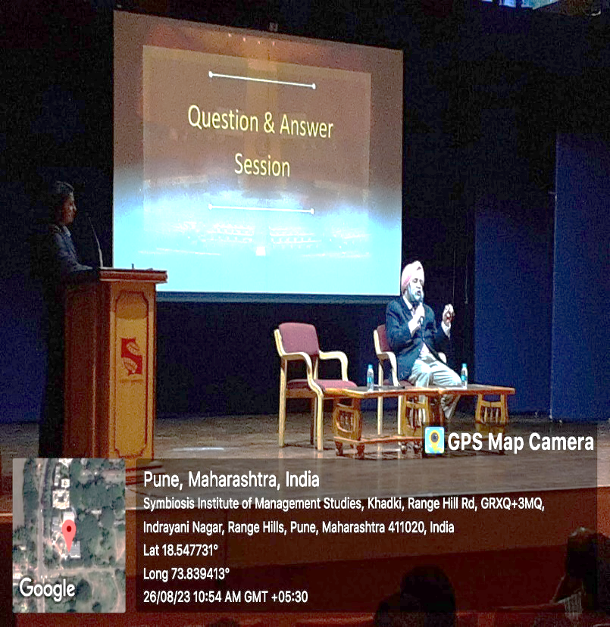

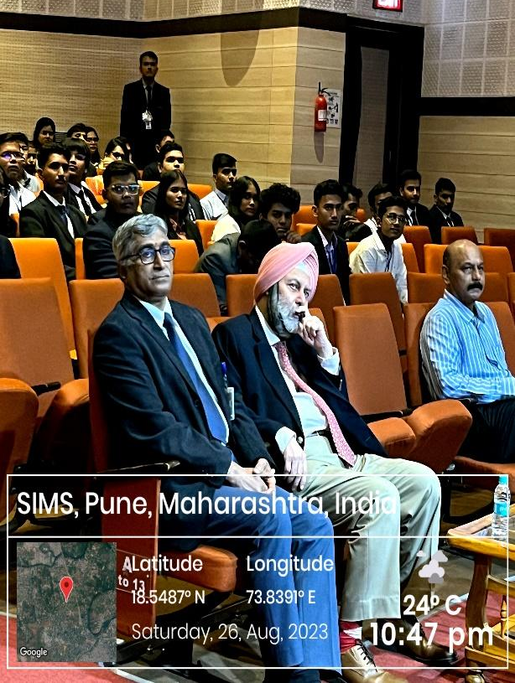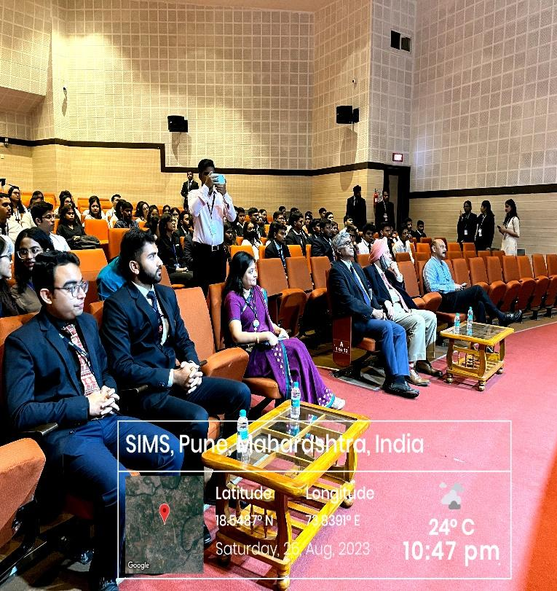

Organizing Committee Members:

 | Organizing Committee
S.No. | Name | Year
 | Office Bearer
1. | Ankush Dhiman, Secretary General | 2nd Year
2. | Adarsh Kumar Mishra, Director General | 2nd Year
3. | Anubhab Chattopadhyay, Deputy Director General | 2nd Year
 | Under-Secretaries
4. | Shubhangi Bisht, Delegations and Outreach | 2nd Year
5. | Ishan Sadanand, Marketing and External affairs | 2nd Year
6. | Ayush Mahapatra, Logistics and Finance | 2nd Year
7. | Shashank Tripathy, PR, and Creatives | 2nd Year
 | Junior Secretariat
8. | Varun Panwar | 1st Year
9. | Srishti Jha | 1st Year
10. | Andrea Rodrigues | 1st Year
11. | Shanu S | 1st Year
12. | Tripti Gupta | 1st Year
13. | Navroz Dewan | 1st Year
14. | Vaibhav Mishra | 1st Year
15. | Arunjai Agarwal | 1st Year
16. | Shivani Chauhan | 1st Year
17. | Keerthi Priya | 1st Year

List of attendees

Delegates list: UNGA
NAME | COMMITTEE | COUNTRY
Ayoush Singh | UNGA | Pakistan
Harleen Kaur Behal | UNGA | Germany
Amit Sunil Sonar | UNGA | Syrian Arab Republic
Kaustubh Hanumant Pawale | UNGA | Malaysia
Shannon D'Souza | UNGA | New Zealand
Luv Sharma | UNGA | India
Kanika Tripathi | UNGA | Finland
Indu Kumari | UNGA | Democratic Republic of the Congo
Karen Chandel | UNGA | Belgium
Mehak Jain | UNGA | Republic of Korea
Arjun | UNGA | Australia
Kaustav Mukhopadhayay | UNGA | Japan
Mahareddy Ravi Vaishnov | UNGA | Philippines
Modalavalasa Mahesh | UNGA | Ethiopia
Ayush Palni | UNGA | Zimbabwe
Shivani | UNGA | Maldives
Noothanakalava | UNGA | United Arab Emirates
Kunjal Kshavi | UNGA | Denmark
Gaurav Mishra | UNGA | Russian Federation
Prerana Jambrekar | UNGA | Ireland
Nandini Aggarwal | UNGA | United Kingdom
Saumya Suresh Iyengar | UNGA | Ukraine
Pratibha Mishra | UNGA | Hungary
Rudra Pratap Nirwana | UNGA | Brazil
Mohit Modi | UNGA | Egypt
Deepak jha | UNGA | Sudan
Satyam Singh | UNGA | Türkiye
Sohinee Roy | UNGA | Canada
Suruchi Jha | UNGA | Vietnam
Yudhvir | UNGA | Switzerland
Kunal Vikrant Deore | UNGA | Armenia
Tamajit Bhattacharya | UNGA | France
Richi Mohanty | UNGA | Nepal
Alok Mishra | UNGA | Mexico
Siddhant Anil Kulkarni | UNGA | Poland
Ishita Sarkar | UNGA | Sri Lanka
Rachit Chandawar | UNGA | Italy
Abuzar Shaikh | UNGA | China
Utkarsh Singh | UNGA | Saudi Arabia
Aman Mandal | UNGA | USA
Rakeysh Maanoj Gupta | UNGA | Bangladesh
Shivraj Mulik | UNGA | South Africa
Qusai Shergardwala | UNGA | Iraq
Samruddhi Kore | UNGA | Iran
Pranab Vishwakarma | UNGA | Azerbaijan
Priyanka Sharma | UNGA | Spain
Sarthak Baviskar | UNGA | Sweden

Delegates list: UNHCR
Participants from SIMS, Pune
Name | Country | Batch
Kevin J Kurien | Myanmar | 2022-2024
Vinayak Naik | India | 2022-2024
Aashutosh Singh | Nepal | 2022-2024
Akash Singh Rana | South Africa | 2023-2025
Arko Priyo Ghosh | Afghanistan | 2023-2025
Tanmaya Darbhamulla | Morocco | 2023-2025
Manaswi | Iraq | 2023-2025
Anubha Dwivedi | United Kingdom | 2023-2025
Tanvi Saini | South Sudan | 2023-2025
Saipriya | Jordan | 2023-2025
Neha Yadav | Ireland | 2023-2025
Jahanvi Yadav | Greece | 2023-2025
Sehaj Preet Kaur | France | 2023-2025
Kumari Priyanka | Germany | 2023-2025
Smriti Pradhan | Ukraine | 2023-2025
C Riya Reddy | Niger | 2023-2025
Arena Brinda | United Arab Emirates | 2023-2025
Amol Kumar | Norway | 2023-2025
Ishaan Paul Chowdhury | Venezuela | 2023-2025
Nirant Dhumal | Belgium | 2023-2025
Abu Jafar Shaikh | Israel | 2023-2025
Praloy Ghosh | Democratic Republic of the Congo | 2023-2025
Shivani Chourasia | Brazil | 2023-2025
Prerna Anand | Somalia | 2023-2025
Vidit Sahai | Syrian Arab Republic | 2023-2025
Lt Col Prashant R Kakade | Canada | 2022-2024
Dr. GAYATRI BAKHSHI | Denmark | 2023-2025
Advika Kantu | Saudi Arabia | 2023-2025
Aakanksha Singh | Tunisia | 2023-2025
Afifa Alam | Lebanon | 2023-2025
Mrigna Rupaal | Italy | 2023-2025
Ananya Yadav | Burkina Faso | 2023-2025
Shubham Kulkarni | Spain | 2022-2024
Himanshu | Mexico | 2022-2024
Suraj Panwar | Bangladesh | 2022-2024
Anubha Tandon | Türkiye | 2022-2024
Riya Parashar | Sweden | 2022-2024

Participants List (From other colleges)
Name | Country | College
Subodh Jadhav | Sudan | Dhole Patil College of engineering, Pune
Aashay Inamdar | United States of America | COEP Technological University
Nishant Wankhede | Libya | VIT Pune
Riya Sumshette | Russian Federation | The Bishop's Junior College, Camp, Pune
Neha Pisal | Australia | MITWPU, Kothrud, Pune
Sonakshi Ganwani | Pakistan | ILS law college, Pune
Shriparna Ghate | China | Dhole Patil junior college of arts, commerce and science, Pune
Nitish Sharma | Japan | MIT WPU, Pune
Diya Shaikh | Mozambique | VIT, Pune
Harshvardhan Kendre | Republic of Korea | VIT Pune
Aumkar | Yemen | Dhole Patil College of Engineering, Pune
Renuka More | Mongolia | Dhole Patil College of Engineering, Pune
Niranjana P | Finland | Amrita school of business, Bangalore

IP list

Email Address | Name | Committee | Batch
vaishali.taak2024@sims.edu | Vaishali | INTERNATIONAL PRESS | 2022-2024
anjali.rani2024@sims.edu | Anjali Rani | INTERNATIONAL PRESS | 2022-2024
samridh.kaur2025@sims.edu | Samridh Kaur | INTERNATIONAL PRESS | 2023-2025
zainab.chhatriwala2025@sims.edu | Zainab Chhatriwala | INTERNATIONAL PRESS | 2023-2025
minu.jyotsna2025@sims.edu | Minu Jyotsna | INTERNATIONAL PRESS | 2023-2025
sandhyasonkamble539@gmail.com | Sonkamble Sandhyarani | INTERNATIONAL PRESS
eshanighavate@gmail.com | Eshani Ghavate | INTERNATIONAL PRESS
adibhongale999@gmail.com | Aditya Bhongale | INTERNATIONAL PRESS
aryakul14@gmail.com | Arya Kulkarni | INTERNATIONAL PRESS
maithilijagdale20@gmail.com | Maithili Jagdale | INTERNATIONAL PRESS
arg8623810482@gmail.com | Atharv Gavali | INTERNATIONAL PRESS
pratik.dagale21@vit.edu | Pratik Dagale | INTERNATIONAL PRESS
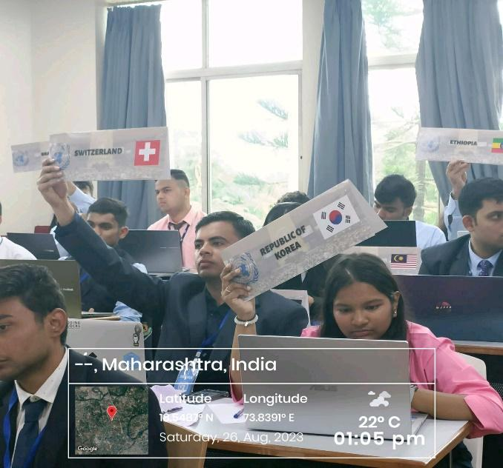
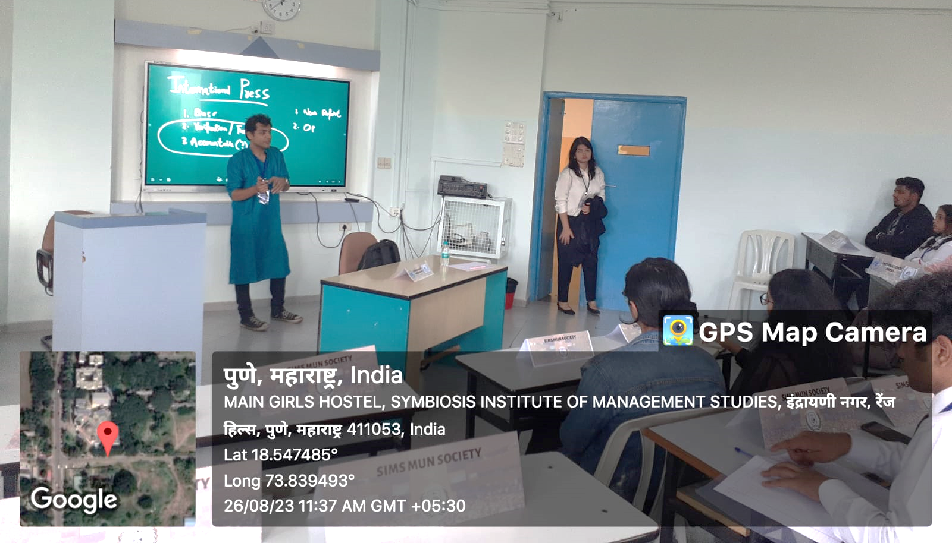

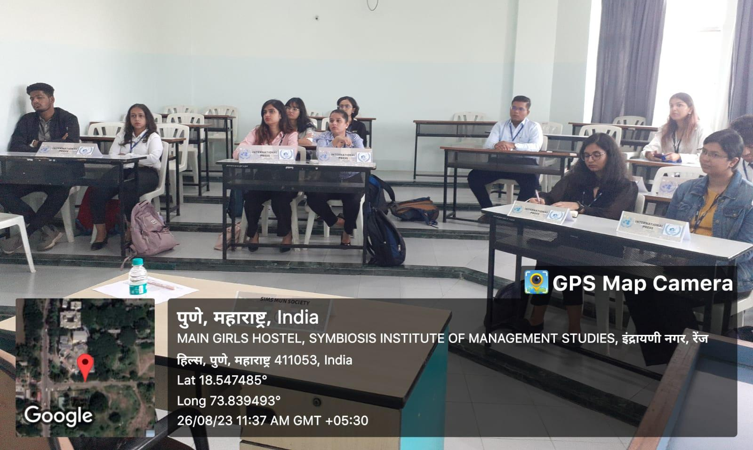

Executive Board members

S.no | Name | Designation
1 | Sanya Deshmukh | Chair (UNHCR)
2 | Shreenija Dandavate | Co- Chair (UNHCR)
3 | Abeer Tiwari | Chair (UNGA)
4 | Darshan Nere | Co-Chair (UNGA)
5 | Manaksh Bhanushali | International Press Head

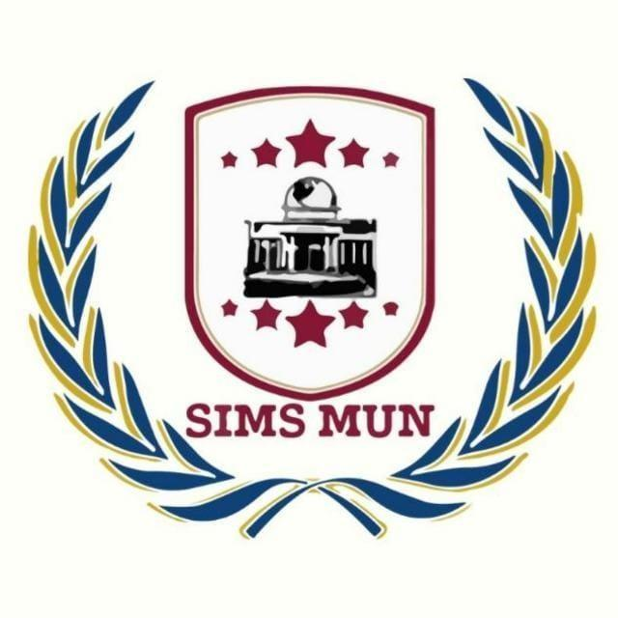
SKILL DEVELOPMENT
SIMS INTER MUN 2023
UNGA Report

Compiled by SIMS MUN Society

Symbiosis Institute of Management Studies, Pune

To: The Director
From: SIMS MUN Society
Respected Sir,
Subject: Report on UNGA Committee of SIMS Intra MUN 2022 conducted on 26th and 27th August 2023

SIMS Inter MUN 2023 was organized by SIMS MUN Society on 20th and 21st February 2023. The opening ceremony of the event was graced by the presence of the esteemed Chief Guest for the event, Amb. (Retd.) Manjeev Singh Puri, Former representative of India to EU, Belgium, Luxembourg, and Nepal. He addressed the August gathering with his thoughts on the future of Model United Nations, drawing on his own experiences and knowledge of India's role in the organization. Brig (Dr.) Rajiv Divekar, Director of SIMS also addressed the gathering with his kind words. Faculty. Others in presence were faculty members of SIMS, participants of SIMS Inter MUN 2023, and the transformational student managers of SIMS.

The audience received the event well. Attached along with this letter, is a brief report of the ceremony and the events that transpired during the session for your perusal. The event was successfully organized under the guidance of Dr. Smita Mehendale, faculty in-charge SIMS MUN Society and leadership of Ankush Dhiman, Secretary General SIMS MUN Society, and Anubhab Chattopadhyay, Deputy Director General, SIMS MUN Society.

As we grow with your support and guidance, we hope to organize many such events in the future.

Sincerely
SIMS MUN Society
REPORT

S.No. | ACTIVITY | REMARKS
1. | Topic | UNGA: 78 years of UNGA: A need for reforms in the UNSC- size of an enlarged council and its working methods.
2. | Duration | Date:26th and 27th August 2023  Time: 10 AM to 5 PM
3. | Invitations | Honourable Chief Guest Amb. Manjeev Singh Puri; Director SIMS, Brig. (Dr.) Rajiv Divekar; Dr. Smita Mehendale, faculty in-charge SIMS MUN Society; Participants of SIMS Inter MUN 2023 and Transformational Student Managers of SIMS.
4. | Participants | - 43 Delegates  - 4 members of the executive board  - Organizing Committee (On Rotation)  - 6 Members of International Press
5. | Objectives | - To discuss how to increase the representation of developing countries in the UNSC. The current UNSC is made up of five permanent members (China, France, Russia, the United Kingdom, and the United States) and ten rotating members. This gives a disproportionate amount of power to the permanent members, who can veto any UNSC resolution.  - Finding out ways to reform the UNSC's working methods. The UNSC's working methods are often seen as being secretive and undemocratic.
6. | Outcomes | Delegates had an enriching debate on ways to increase the involvement of developing nations in UNSC that would help to ensure that the council is more representative of the global community and that its decisions are more reflective of the interests of all UN member states.  Delegates had a discussion on the reforms that could be made to make the council's deliberations more transparent and inclusive, and to give all UN member states a greater say in the council's decision-making process.

Table Programme

UNGA Report
SIMS INTER MUN 2023

SIMS Inter MUN 2023 started off with the inaugural session which was addressed by our honorable chief guest Amb. Manjeev Singh Puri, Former ambassador of India to Nepal. He spoke about the importance of UN and the world coming together as one big family and the need for more involvement of developing nations in UNSC that would help to ensure that the council is more representative of the global community and that its decisions are more reflective of the interests of all UN member states.
He also addressed the students as the future of the world and reminded them of some esteemed officers in the defence field who fought for the betterment and protection of our country. The session witnessed the presence of Brig. (Dr.) Rajiv Divekar, Director of SIMS; Assistant Professor-Dr. Smita Mehendale, faculty in-charge of SIMS MUN Society; faculty members of SIMS and participants of SIMS Inter MUN 2023. Post the inaugural session the delegates moved to their respective committees to start the discussion. There were three committees this year namely, UNHCR, UNGA and the International Press.
The total number of participants in UNGA was forty-three. The committee started with the RoP (Rules of Procedure) session taken by the chairs to clear the queries of the delegates regarding the proceedings of the committee. All the doubts of the delegates regarding the proceedings and formalities were resolved by the chairs prior to the formal committee proceedings, following which the committee entered the formal deliberations and speeches where delegates raised prominent issues related to the set agenda.
The United Nations General Assembly started the formal committee proceedings, and the debate that followed was a heated one, with countries expressing their views on the concerned topic “UNGA: 78 years of UNGA: A need for reforms in the UNSC- size of an enlarged council and its working methods.”
Shifting Tides: The Twilight of Veto Power and the Dawn of Unified Action 26th August 2023
The delegate of Ukraine exposed the limitations of the UNSC and why there is an urgent need for reform. Ukraine’s delegate talked about how Russia's attack against Ukraine was not limited to the war. With their veto privilege, they also effectively hindered the UNSC from intervening in aid to Ukraine. They talked about how being influenced by such power puts other nations at a disadvantage since the P5 make decisions that cater to their nation's personal interest, which then goes against the very essence of the United nation.
On day two, the conference commenced with India drawing attention to its status as the world's most populous country, representing a massive portion of the global population. They showcased recent achievements such as the Chandrayaan launch and the growth of their GDP and economy. India argued that their evolving global role justifies a permanent seat on the UNSC. As discussions unfolded, India found support from France and the United Kingdom.
According to the delegate of Poland, "Rather than taking responsible actions against the territorial aggressions in various regions, Russia themselves have been involved in the aggression adventures". Sweden, Ireland, Ukraine, and Brazil have all highlighted instances where Russia has misused its authority to serve personal interests.
Ukraine’s delegate stated that "Russia's savage blitz on Ukraine is a stark reminder of the UNSC's impotence when the interests of one or more of the P5 conflict with those of the other members." most of the nation’s agree that Russia's aggressive actions against Ukraine underscore the UNSC's inability to address conflicts arising between the P5 and other member states.
Russian delegate, however, refutes these allegations, asserting that its actions are in its national interest and not a form of aggression.
Similarly, China’s delegate has been criticized for misusing its P5 status to exert pressure on smaller Asian nations. The delegates of Malaysia and Nepal have condemned China's behavior as "bullying."
Pakistan’s delegate further points out India's role in obstructing their progress and sees India's potential permanent seat in the UNSC as a Threat to Pakistan. In conclusion, the recent discussions underscore the pressing need to reform the UNSC to ensure it remains effective in addressing contemporary global challenges.
Conversely, delegates of countries like Maldives, Sweden, Poland, Saudi Arabia, Nepal, Azerbaijan, Spain, and Iraq strongly opposed the P5's veto power. These nations observed that the veto system grants an unfair advantage to the P5, leaving smaller nations in a perpetual power struggle.
Surprisingly, delegates of China and Pakistan shifted their stance on UNSC expansion, now expressing support for it. Delegate of China suggested granting more power to South African countries while still retaining some control.
Sweden’s delegate noted that since 1950, the UNSC has expanded its original size four times, magnifying its influence over the UNGA. They drew parallels between this expansion and the undemocratic nature of the veto system.
In conclusion, the recent discussions underscore the pressing need to reform the UNSC to ensure it remains effective in addressing contemporary global challenges. The concerns expressed by various nations highlight the imperative of a more representative and dynamic council structure to navigate the complexities of the evolving world order.

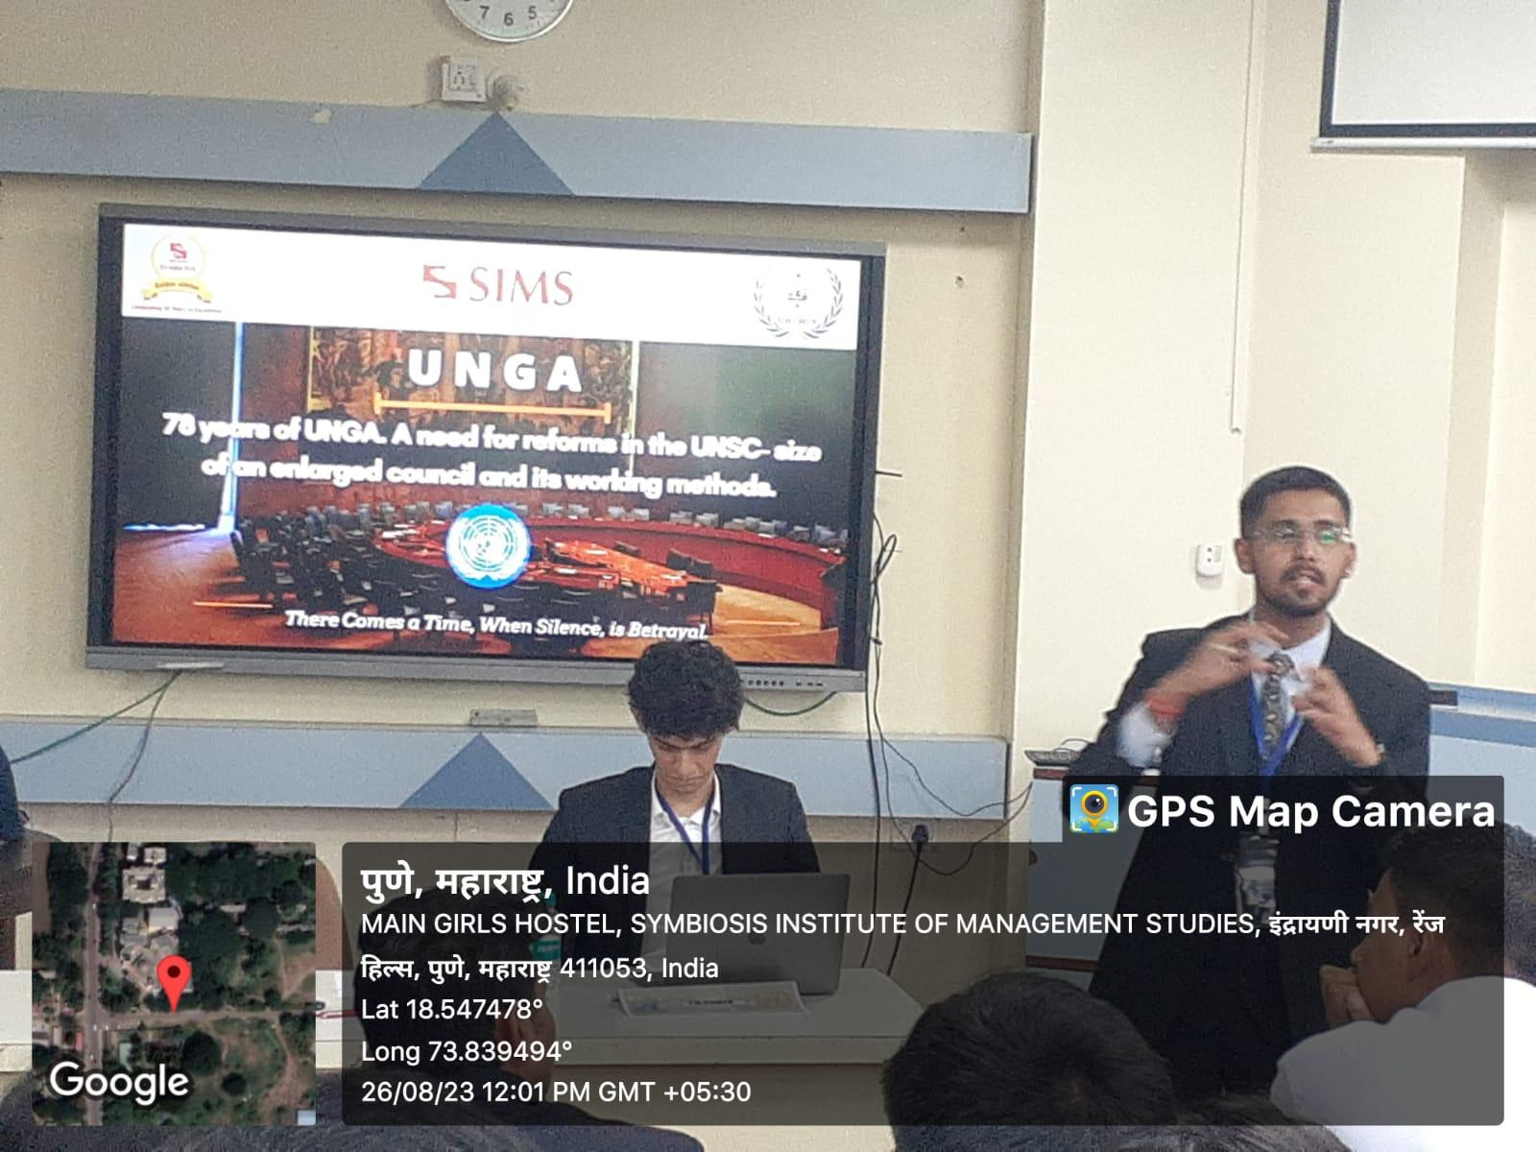

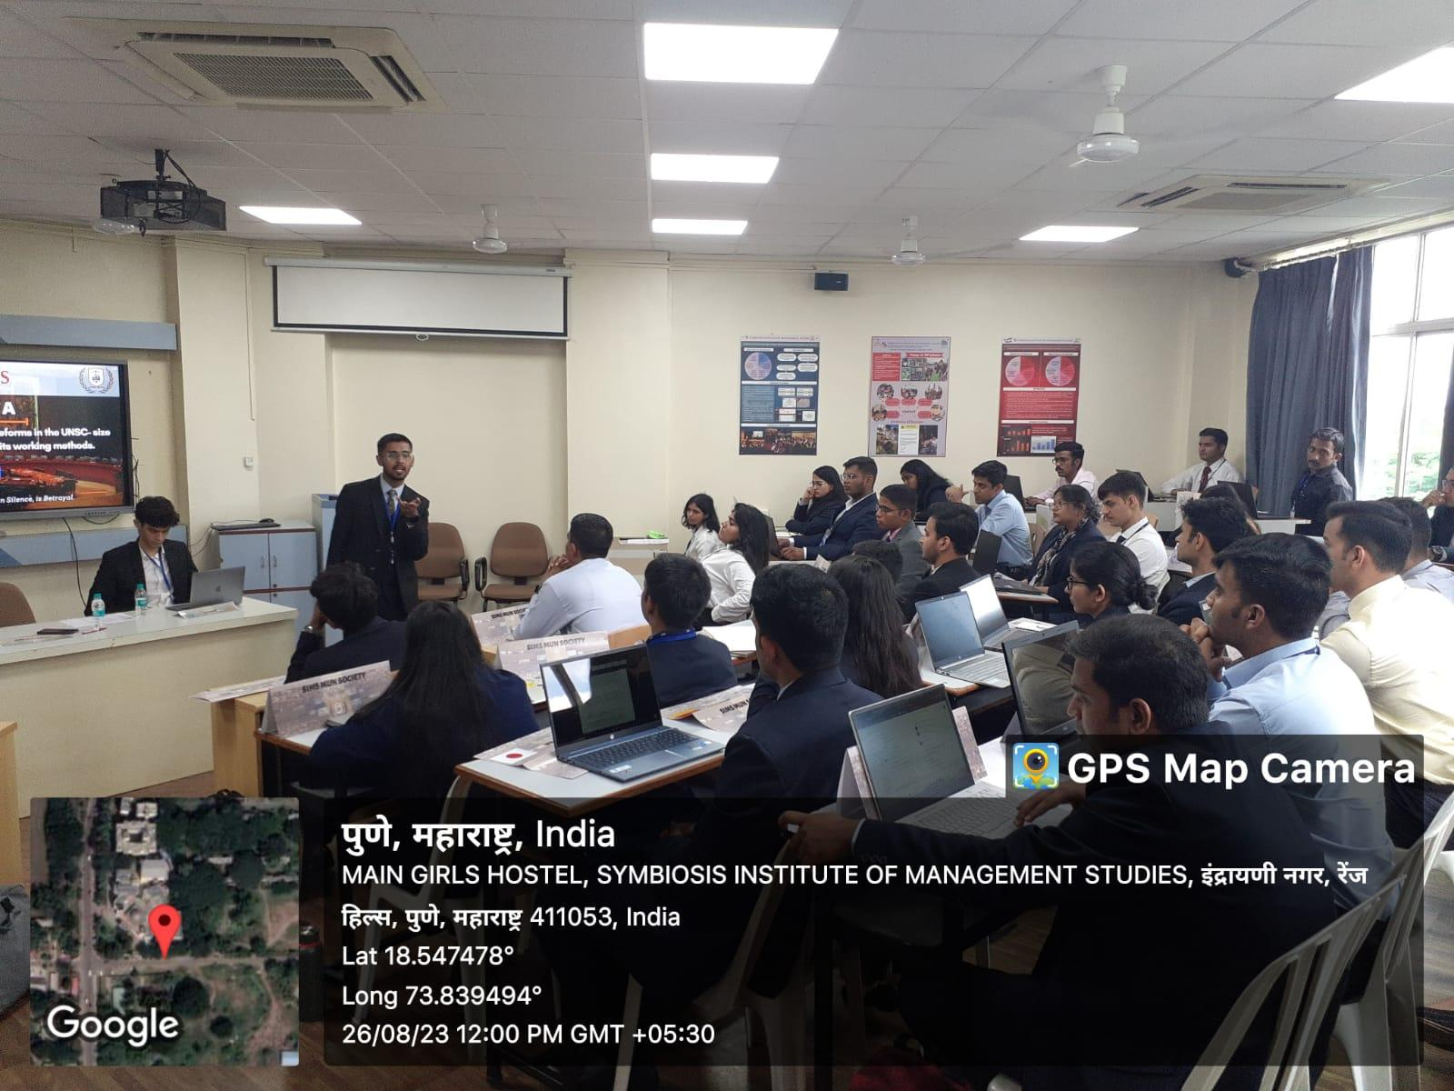

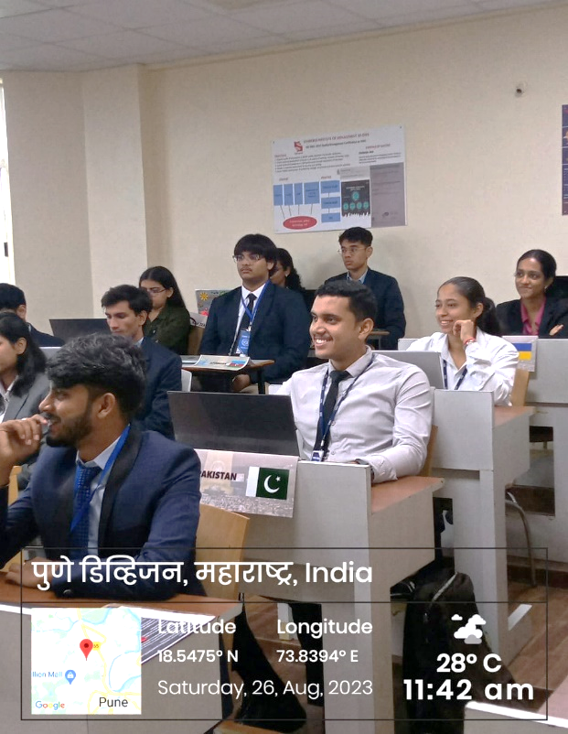

The winners of the UNGA Committee were as follows:
UNGA
- Joint High Commendation: Sarthak Baviskar – Sweden; Rakeysh Maanoj Gupta – Bangladesh
- Special Mention: Rachit Chandawar - Italy
- Verbal Mention: Richi Mohanty – Nepal; Siddhant Anil Kulkarni- Poland; Qusai Shergardwala - Iraq

Organizing Committee Members:
 | Organizing Committee
S.No. | Name | Year
 | Office Bearer
1. | Ankush Dhiman, Secretary General | 2nd Year
2. | Adarsh Kumar Mishra, Director General | 2nd Year
3. | Anubhab Chattopadhyay, Deputy Director General | 2nd Year
 | Under-Secretaries
4. | Shubhangi Bisht, Delegations and Outreach | 2nd Year
5. | Ishan Sadanand, Marketing and External affairs | 2nd Year
6. | Ayush Mahapatra, Logistics and Finance | 2nd Year
7. | Shashank Tripathy, PR, and Creatives | 2nd Year
 | Junior Secretariat
8. | Varun Panwar | 1st Year
9. | Srishti Jha | 1st Year
10. | Andrea Rodrigues | 1st Year
11. | Shanu S | 1st Year
12. | Tripti Gupta | 1st Year
13. | Navroz Dewan | 1st Year
14. | Vaibhav Mishra | 1st Year
15. | Arunjai Agarwal | 1st Year
16. | Shivani Chauhan | 1st Year
17. | Keerthi Priya | 1st Year

Participants list
NAME | COMMITTEE | COUNTRY
Ayoush Singh | UNGA | Pakistan
Harleen Kaur Behal | UNGA | Germany
Amit Sunil Sonar | UNGA | Syrian Arab Republic
Kaustubh Hanumant Pawale | UNGA | Malaysia
Shannon D'Souza | UNGA | New Zealand
Luv Sharma | UNGA | India
Kanika Tripathi | UNGA | Finland
Indu Kumari | UNGA | Democratic Republic of the Congo
Karen Chandel | UNGA | Belgium
Mehak Jain | UNGA | Republic of Korea
Arjun | UNGA | Australia
Kaustav Mukhopadhayay | UNGA | Japan
Mahareddy Ravi Vaishnov | UNGA | Philippines
Modalavalasa Mahesh | UNGA | Ethiopia
Ayush Palni | UNGA | Zimbabwe
Shivani | UNGA | Maldives
Noothanakalava | UNGA | United Arab Emirates
Kunjal Kshavi | UNGA | Denmark
Gaurav Mishra | UNGA | Russian Federation
Prerana Jambrekar | UNGA | Ireland
Nandini Aggarwal | UNGA | United Kingdom
Saumya Suresh Iyengar | UNGA | Ukraine
Pratibha Mishra | UNGA | Hungary
Rudra Pratap Nirwana | UNGA | Brazil
Mohit Modi | UNGA | Egypt
Deepak jha | UNGA | Sudan
Satyam Singh | UNGA | Türkiye
Sohinee Roy | UNGA | Canada
Suruchi Jha | UNGA | Vietnam
Yudhvir | UNGA | Switzerland
Kunal Vikrant Deore | UNGA | Armenia
Tamajit Bhattacharya | UNGA | France
Richi Mohanty | UNGA | Nepal
Alok Mishra | UNGA | Mexico
Siddhant Anil Kulkarni | UNGA | Poland
Ishita Sarkar | UNGA | Sri Lanka
Rachit Chandawar | UNGA | Italy
Abuzar Shaikh | UNGA | China
Utkarsh Singh | UNGA | Saudi Arabia
Aman Mandal | UNGA | USA
Rakeysh Maanoj Gupta | UNGA | Bangladesh
Shivraj Mulik | UNGA | South Africa
Qusai Shergardwala | UNGA | Iraq
Samruddhi Kore | UNGA | Iran
Pranab Vishwakarma | UNGA | Azerbaijan
Priyanka Sharma | UNGA | Spain
Sarthak Baviskar | UNGA | Sweden

Executive Board Members:

Name
Abeer Tiwari, Chair
Darshan Nere, Co-chair

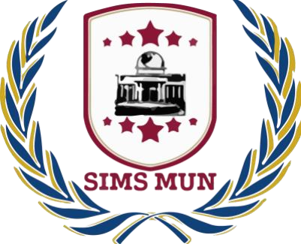

SKILL DEVELOPMENT

SIMS INTER MUN 2023

UNHCR Report

Compiled by SIMS MUN Society

Symbiosis Institute of Management Studies, Pune

To: The Director
From: SIMS MUN Society
Respected Sir,
Subject: Report on UNHCR Committee of SIMS Inter MUN 2023 conducted on 26th and 27th August 2023

SIMS Inter MUN 2023 was organized by SIMS MUN Society on 26th and 27th August 2023. The opening ceremony of the event was graced by the presence of the esteemed chief guest Amb. Manjeev Singh Puri, Representative of India to the United Nations, he spoke about the importance of UN and the world coming together as one big family and the need for more stringent laws to fight terrorism and addressed the students as the future of the world. Brig (Dr.) Rajiv Divekar, Director of SIMS also addressed the gathering with his kind words. Others in presence were Dr. Smita Mehendale, faculty in-charge SIMS MUN Society, participants of SIMS Inter MUN 2023, and the transformational student managers of SIMS.
The audience received the event well. Attached along with this letter, is a brief report of the ceremony and the events that transpired during the session for your perusal. The event was successfully organized under the guidance of Dr. Smita Mehendale, faculty in-charge SIMS MUN Society, Secretary General SIMS MUN Society Ankush Dhiman, and Director General Adarsh Mishra, SIMS MUN Society.
As we grow with your support and guidance, we hope to organize many such events in the future.

Sincerely
SIMS MUN Society

Report

S.No. | ACTIVITY | REMARKS
1. | Topic | UNHCR Agenda: Discussing the global refugee crisis, in light of the ongoing turmoil in Europe.
2. | Duration | Date:26th and 27th August 2023  Time: 11:30 AM to 4:50 PM – 26th August 2023  Time: 10:30 AM to 4:30 PM – 27th August 2023
3. | Invitations | Honourable Chief Guest Amb. Manjeev Singh Puri; Director SIMS, Brig. (Dr.) Rajiv Divekar; Faculty in-charge Dr. Smita Mehendale; Participants of SIMS Inter MUN 2023 and Transformational Student Managers of SIMS.
4. | Participants | - 49 Delegates  - 2 members of the executive board  - Organizing Committee (On Rotation)  - 6 Members of International Press
5. | Objectives | - To discuss the impact of the global refugee crisis, its causes, and workable solutions.  - To find out the ways of addressing the refugee crisis and its future to felicitate the refugees and even to reduce the number of emerging refugees.
6. | Outcomes | Delegates had an enriching debate on ways to make sure that the global refugee crisis is addressed by providing solutions which will not just reduce the refugee crisis but also reduce the changes of such in the future.

TABLE PROGRAMME

UNHCR Report
SIMS INTER MUN 2023

Refugee crisis and global quest for solutions

“If we are to deliberate and find solutions to the refugee crisis, it is time that we avoid hypocrisy and address the lack of transparency present at this forum.”
These were the sharp remarks of the USA delegate aimed at the Russian delegate during the United Nations High Commissioner for Refugees (UNHCR) meeting. The Russian delegate had previously iterated that the refugee crisis is a matter of shared responsibility and conflict is not the only reason behind the crisis. The delegate of USA was quick to question Russia’s stance in front of delegates from 28 countries in attendance.
The discussions covered each country’s stand on the issue as well as possible solutions and steps that can be taken to mitigate the issue on an international scale.
The Indian delegate was the first to present their country’s stand. They spoke about compassion and collective responsibility and how the country was ready to play its part in helping avert the crisis. India also presented possible solutions like implementing early warning systems for crisis situations actively taking place, creation of an international database for job opportunities for refugees, and mental health programs for displaced people.
In similar lines, the Moroccan delegate, too, suggested possible solutions like drafting proper policies to protect sensitive interest of people, establishing a committee that investigates the safety, security, employment, and economic welfare of refugee, and implementing safe pathway plans and options for displaced people on the move from areas of conflict.
While discussing its stand on the current refugee crisis in Europe, the South African delegate pointed out that Europe’s colonial past has come back to haunt it. They further added that colonialism played an important in destabilizing many countries in the world, the effects of which can still be felt today.
The Spanish delegate while agreeing to the point made, added that little could be achieved by blaming the past. Instead, delegate of Spain insisted that focus be brought to enhancing best practices for welcoming refugees, investing in sustainable development, prioritizing human rights protection, and encouraging better dialogue between countries.
On the 2nd day of the event, the spotlight was on the USA when their own hypocrisy was questioned by the Committee when the USA delegate tried to defend their National Security policy that caps refugee intake.
The USA delegate while in support of allowing refugees, fiercely defended its strict immigration and border petrol policies. The USA delegate spoke about the drug cartels operating internationally, and particularly, in South American countries that use refugees as possible drug mules to get illegal drugs inside the USA border.
Offering another perspective, Syrian delegate, an active conflict zone put forth some interesting points. The delegate of Syria appealed to the committee to stop the ongoing international proxy wars that has affected it immensely. As a beacon of hope, Syrian delegate proudly mentioned its efforts to ensure that the education rate within the country, despite the conflict, is maintained at 86%. It made a vehement appeal to increase the funding efforts to Syria, so that the country can invest in its infrastructure and provide cash incentives to people affected by poverty.
Focusing on offering solutions, the South Korean delegate emphasized the importance of providing legal support to refugees in their host countries. Adding to this, the Indian delegate spoke about the work permits. As about 56% of host countries do not permit employment of refugees, India advocated the need for allowing employment to refugees.
Ultimately, the integration and assimilation of refugees within their host countries is important for them to become a part of their new society.

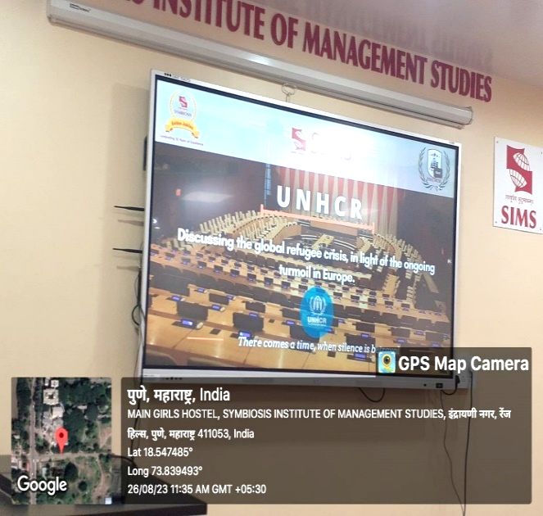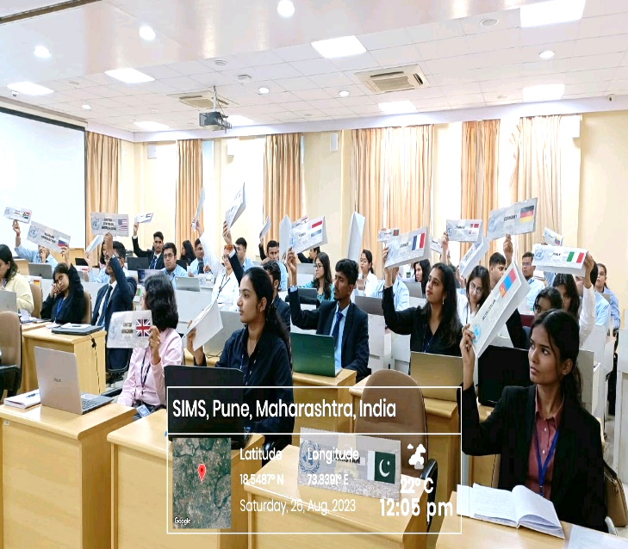
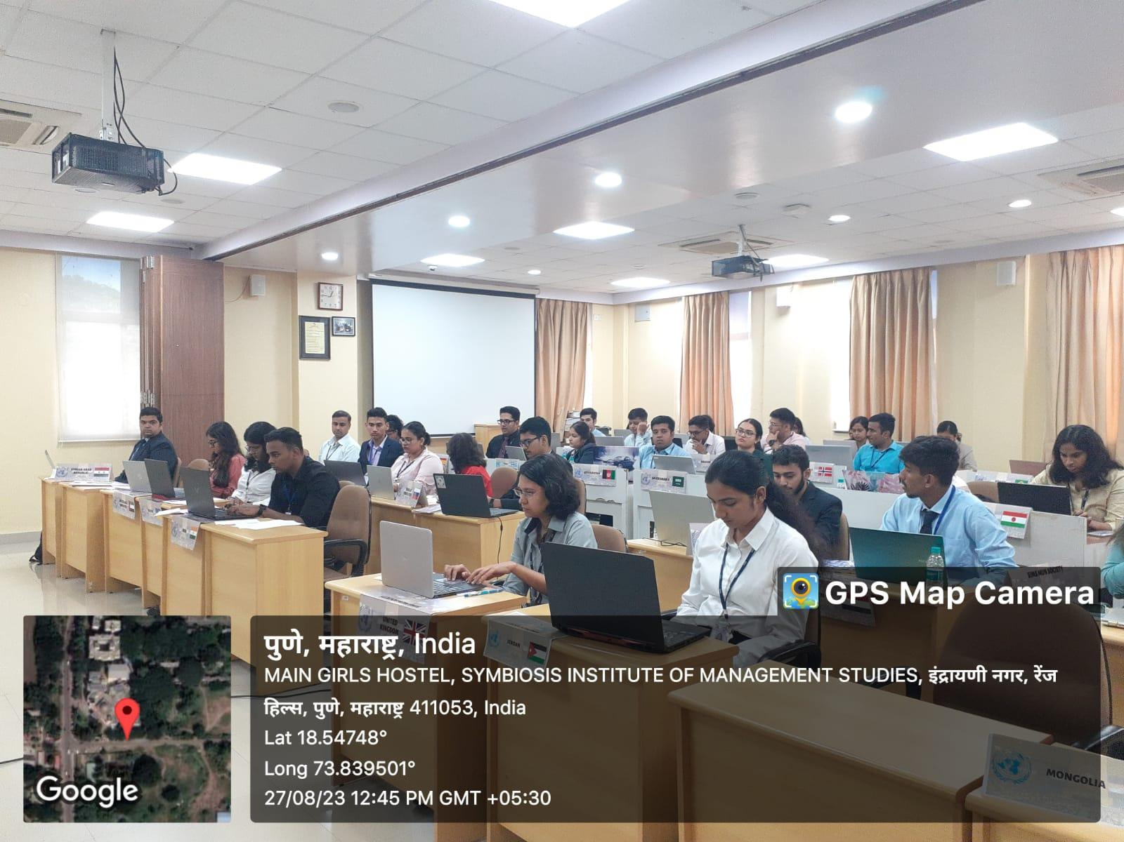

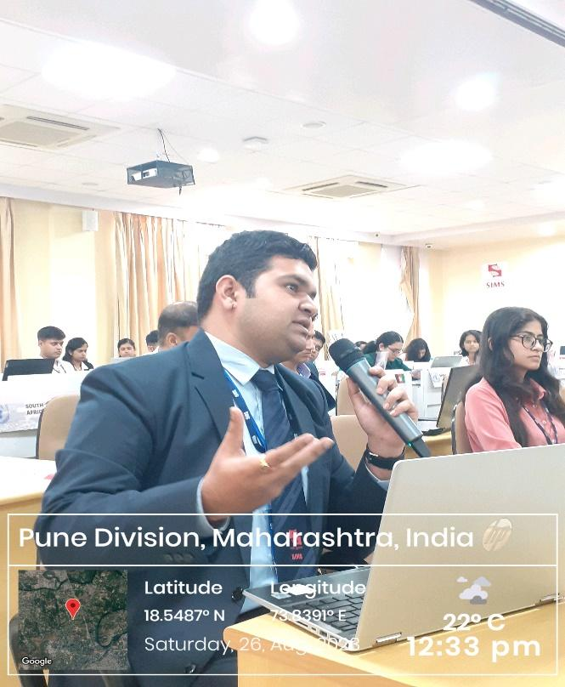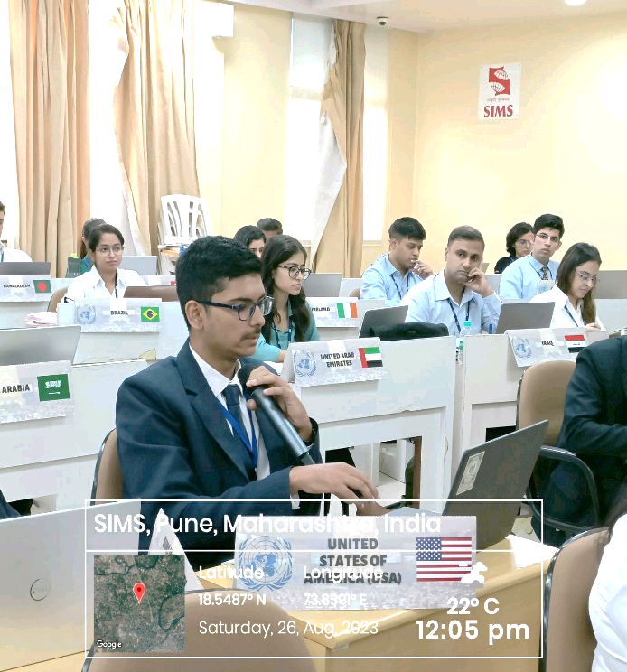

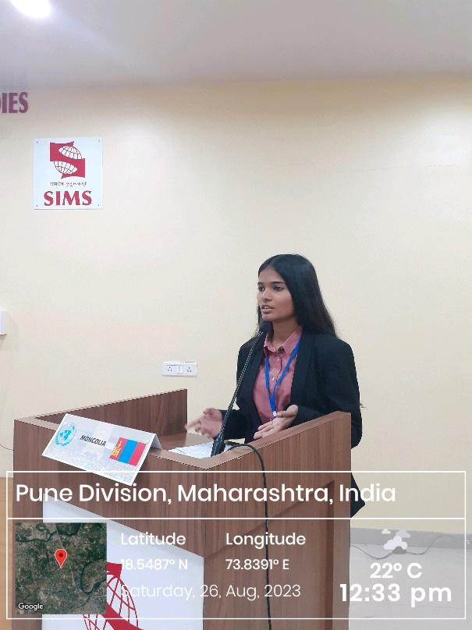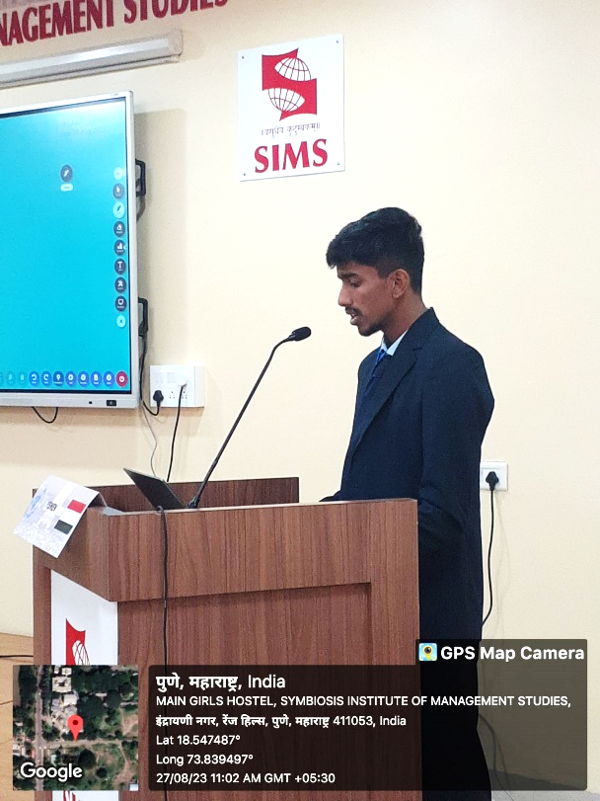

The winners of the UNHCR Committee were as follows:
Best Delegate: Vinayak Naik – India
High Commendation: Aashay Inamdar - USA
Special Mention: Vidit Sahai – Syria Arab Republic
Verbal Mention: Nitish Sharma – Japan; Jahanvi Yadav – Greece; Shubham Kulkarni - Spain

Organizing Committee

 | Organizing Committee
S.No. | Name | Year
 | Office Bearer
1. | Ankush Dhiman, Secretary General | 2nd Year
2. | Adarsh Kumar Mishra, Director General | 2nd Year
3. | Anubhab Chattopadhyay, Deputy Director General | 2nd Year
 | Under-Secretaries
4. | Shubhangi Bisht, Delegations and Outreach | 2nd Year
5. | Ishan Sadanand, Marketing and External affairs | 2nd Year
6. | Ayush Mahapatra, Logistics and Finance | 2nd Year
7. | Shashank Tripathy, PR, and Creatives | 2nd Year
 | Junior Secretariat
8. | Varun Panwar | 1st Year
9. | Srishti Jha | 1st Year
10. | Andrea Rodrigues | 1st Year
11. | Shanu S | 1st Year
12. | Tripti Gupta | 1st Year
13. | Navroz Dewan | 1st Year
14. | Vaibhav Mishra | 1st Year
15. | Arunjai Agarwal | 1st Year
16. | Shivani Chauhan | 1st Year
17. | Keerthi Priya | 1st Year

Participants List (SIMS, Pune)
Name | Country | Batch
Kevin J Kurien | Myanmar | 2022-2024
Vinayak Naik | India | 2022-2024
Aashutosh Singh | Nepal | 2022-2024
Akash Singh Rana | South Africa | 2023-2025
Arko Priyo Ghosh | Afghanistan | 2023-2025
Tanmaya Darbhamulla | Morocco | 2023-2025
Manaswi | Iraq | 2023-2025
Anubha Dwivedi | United Kingdom | 2023-2025
Tanvi Saini | South Sudan | 2023-2025
Saipriya | Jordan | 2023-2025
Neha Yadav | Ireland | 2023-2025
Jahanvi Yadav | Greece | 2023-2025
Sehaj Preet Kaur | France | 2023-2025
Kumari Priyanka | Germany | 2023-2025
Smriti Pradhan | Ukraine | 2023-2025
C Riya Reddy | Niger | 2023-2025
Arena Brinda | United Arab Emirates | 2023-2025
Amol Kumar | Norway | 2023-2025
Ishaan Paul Chowdhury | Venezuela | 2023-2025
Nirant Dhumal | Belgium | 2023-2025
Abu Jafar Shaikh | Israel | 2023-2025
Praloy Ghosh | Democratic Republic of the Congo | 2023-2025
Shivani Chourasia | Brazil | 2023-2025
Prerna Anand | Somalia | 2023-2025
Vidit Sahai | Syrian Arab Republic | 2023-2025
Lt Col Prashant R Kakade | Canada | 2022-2024
Dr. GAYATRI BAKHSHI | Denmark | 2023-2025
Advika Kantu | Saudi Arabia | 2023-2025
Aakanksha Singh | Tunisia | 2023-2025
Afifa Alam | Lebanon | 2023-2025
Mrigna Rupaal | Italy | 2023-2025
Ananya Yadav | Burkina Faso | 2023-2025
Shubham Kulkarni | Spain | 2022-2024
Himanshu | Mexico | 2022-2024
Suraj Panwar | Bangladesh | 2022-2024
Anubha Tandon | Türkiye | 2022-2024
Riya Parashar | Sweden | 2022-2024

Participants List (From other colleges)
Name | Country | College
Subodh Jadhav | Sudan | Dhole Patil College of engineering, Pune
Aashay Inamdar | United States of America | COEP Technological University
Nishant Wankhede | Libya | VIT, Pune
Riya Sumshette | Russian Federation | The Bishop's Junior College, Camp, Pune
Neha Pisal | Australia | MITWPU, Kothrud, Pune
Sonakshi Ganwani | Pakistan | ILS law college, Pune
Shriparna Ghate | China | Dhole patil junior college of arts, commerce and science, Pune
Nitish Sharma | Japan | MIT WPU, Pune
Diya Shaikh | Mozambique | VIT, Pune
Harshvardhan Kendre | Republic of Korea | VIT Pune
Aumkar | Yemen | Dhole Patil College of Engineering, Pune
Renuka More | Mongolia | Dhole Patil College of Engineering, Pune
Niranjana P | Finland | Amrita school of business, Bangalore

Executive Board Members
Name
Sanya Deshmukh, Chair
Shreenija Dandavate, Co-chair

Feedback
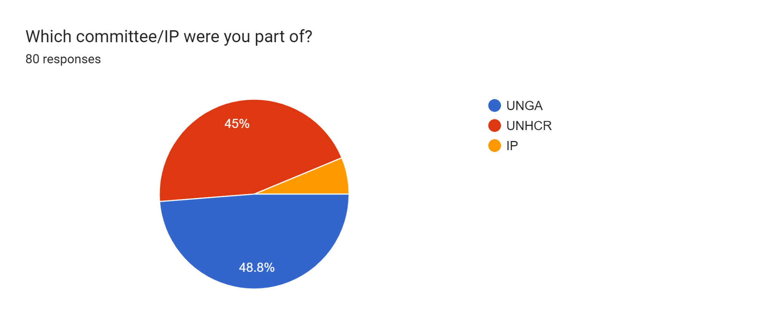
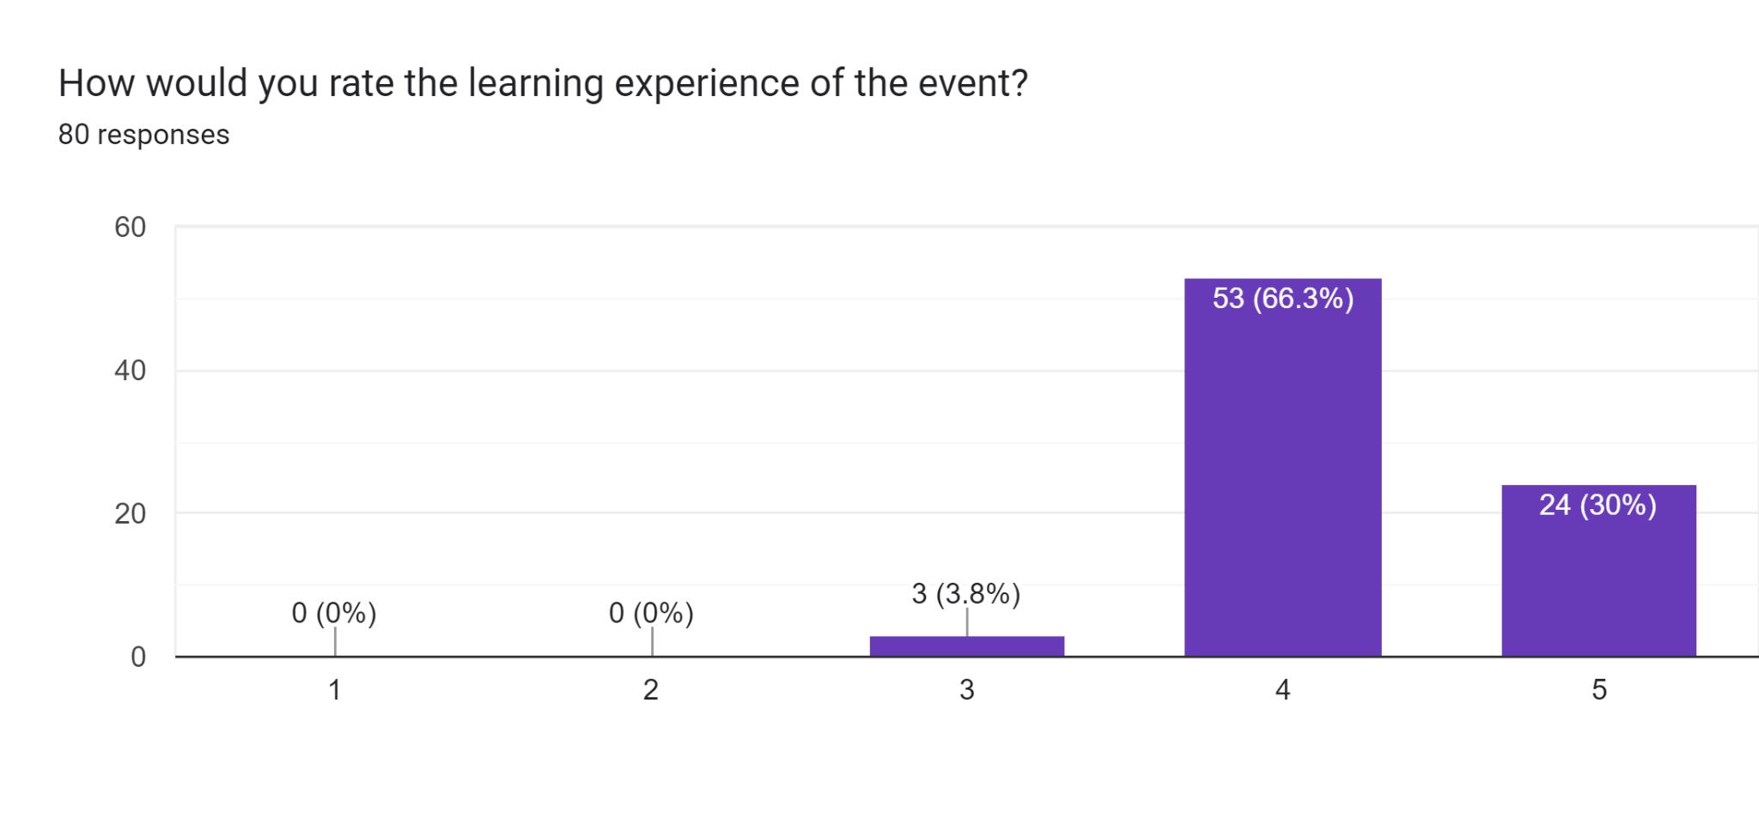
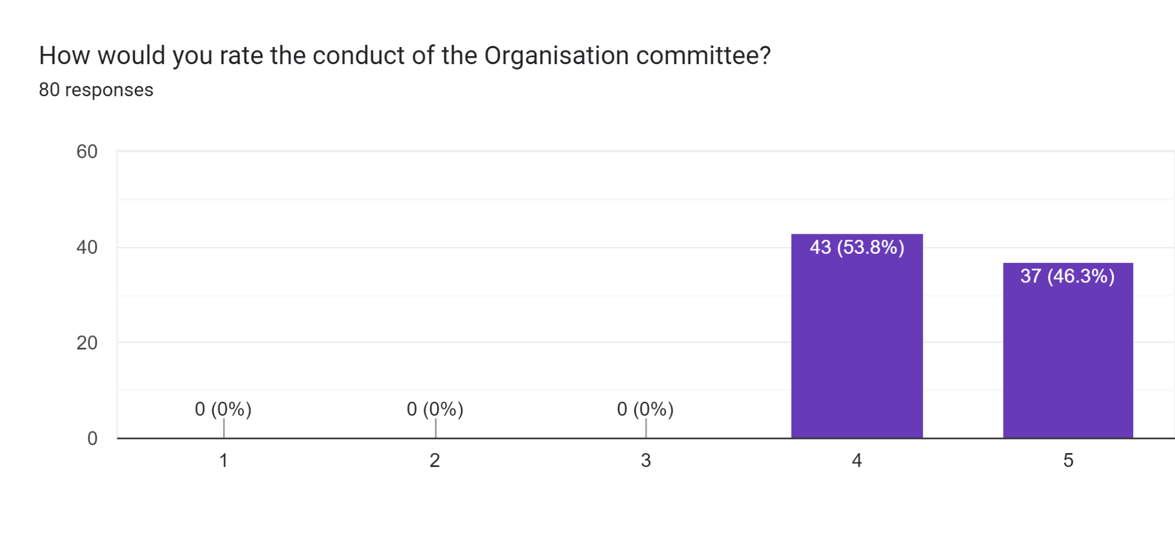
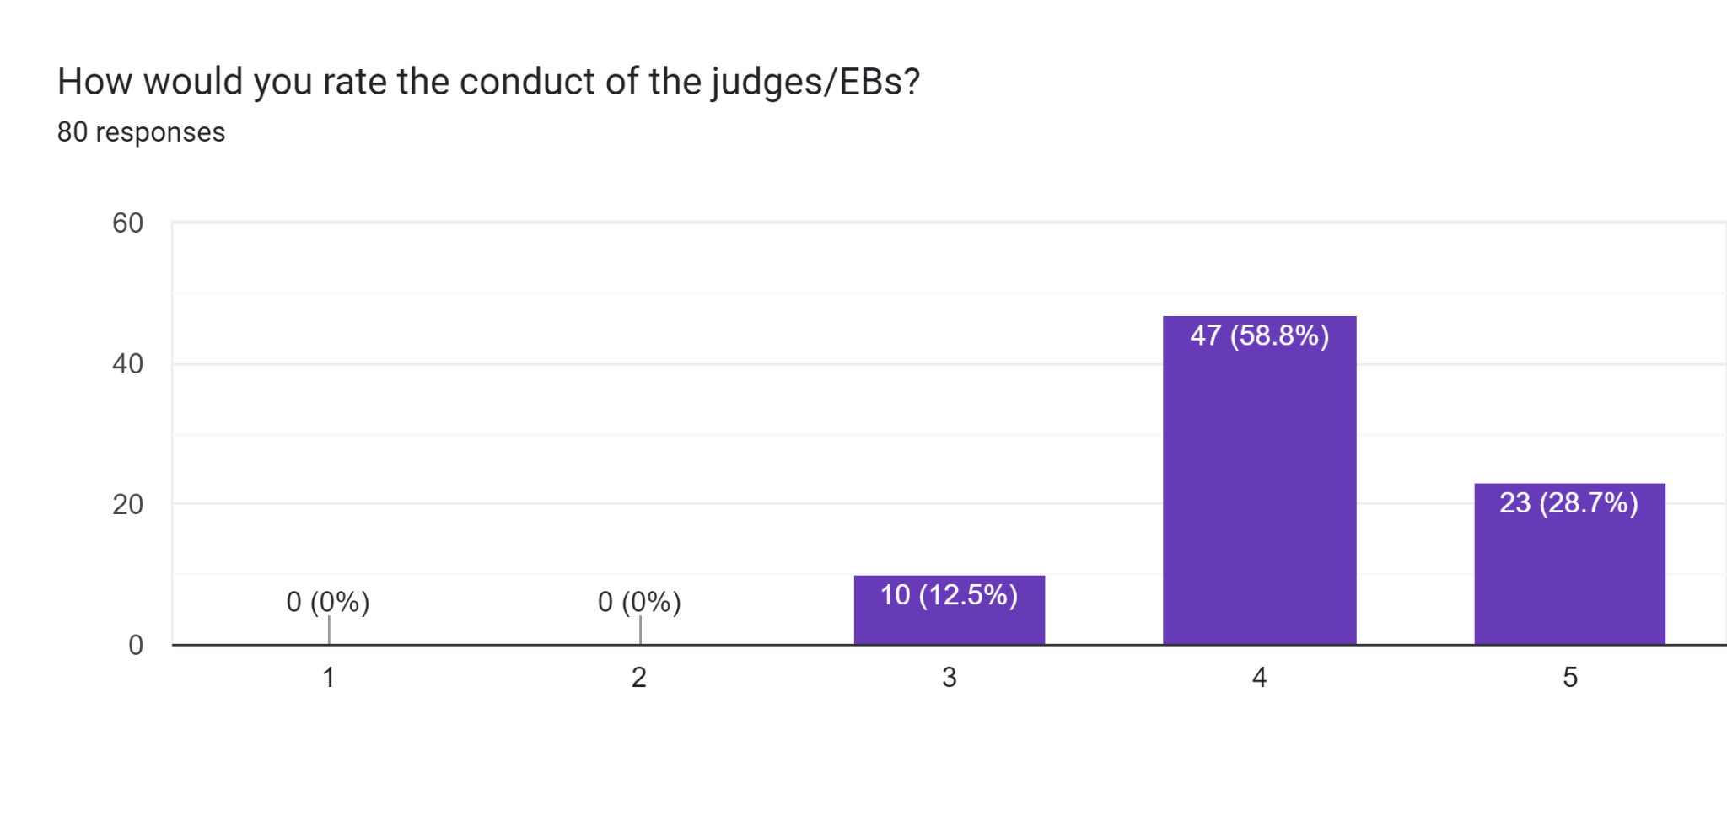
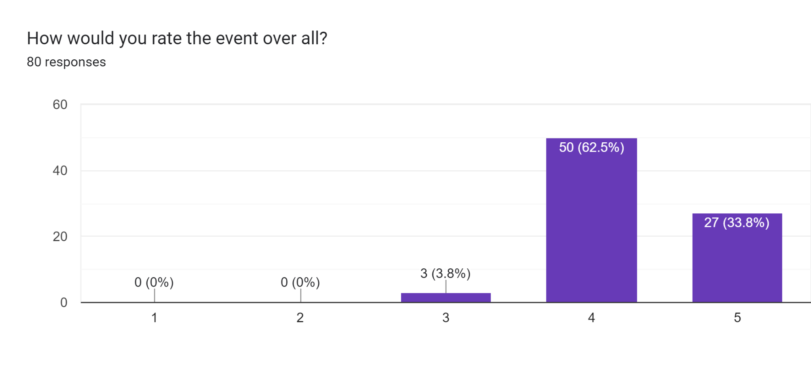
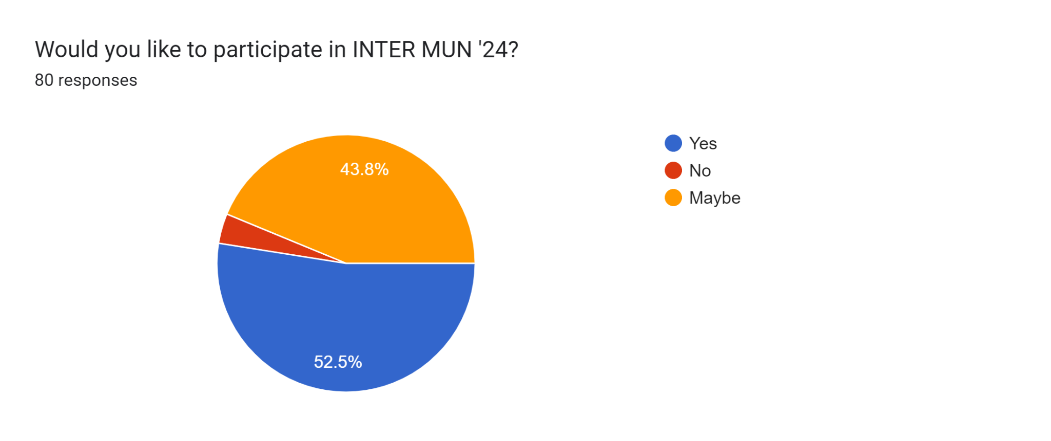

Suggestions and Feedback if any:
This is my first MUN event and I loved it.
great event
quite an insightful event, hope to see you all next time also.
My first experience representing a country, especially Pakistan. Thaks for organizing this event, wouldn't be able to learn so much about the MUN otherwise.
Food can be better.
Nice event. Hope to attend again.
Great event.
The event is good. looking forward to next event.
The team was supportive and gracious. Hopefully will participate again.
great experience representing Syria. Hope to represent another country next time.
enjoyed the debates and discussions a lot.
Loved it.
Great opportunity and learnings.
it was great experience
It was a great event. Also looking forward to youth parliament
I love the job of IP. Hope to become IP next year too.
Good event
Time should be more flexible.
It was a good event
I enjoyed the event a lot
Loved the debate session
Great experience. Hope to represent again next year.
Nice event
Thanks to inter MUN I was able to meet so many people and interact with them. Hope to see them all next year as well.
Great experience
It was my first MUN and I hope to do more in the future.

